The table below lists the market share and average sales volume in dollars for each of the four manufacturers. These measures were obtained by selecting the subset of soft drinks with sub commodity = “12/18 packs of 12 oz. cans” and grouping by manufacturer. Market share is calculated as sum(SALES_VALUE) divided by the combined sum(SALES_VALUE) of all 13 manufacturers.

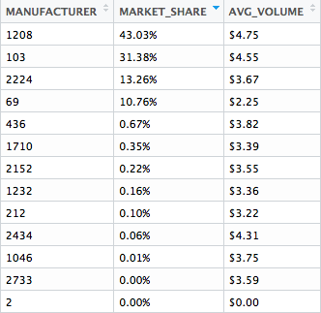

We suspect there there is a seasonal effect but it is not obvious from plotting the weekly sales over time. We will need to check for autocorrelation using the Durbin Watson test.

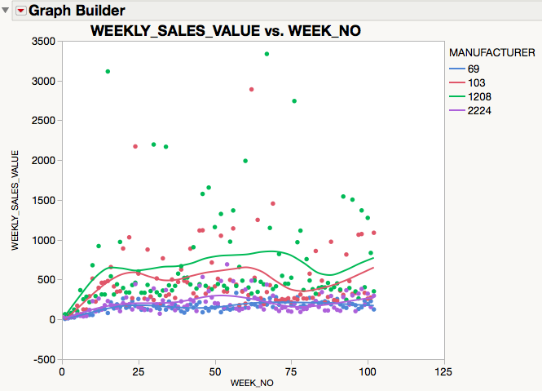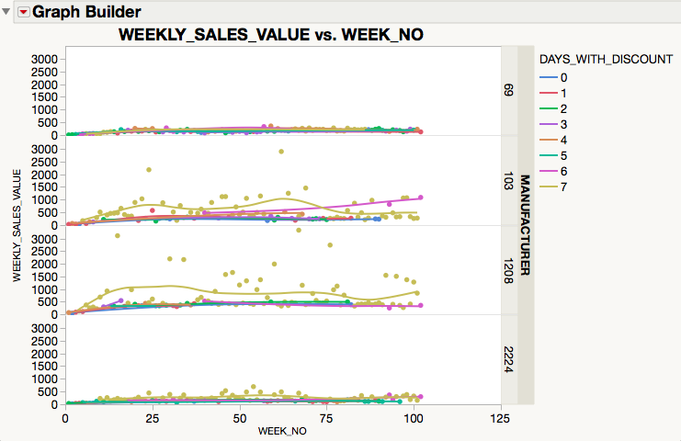

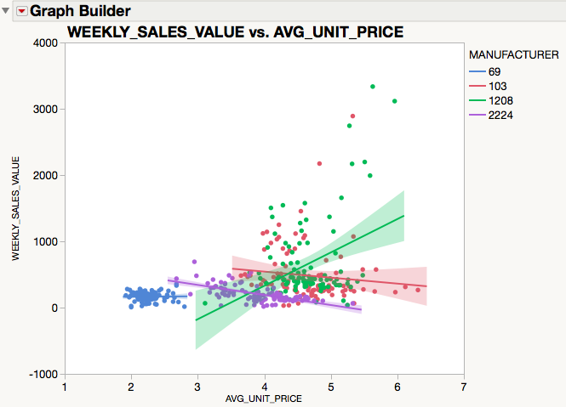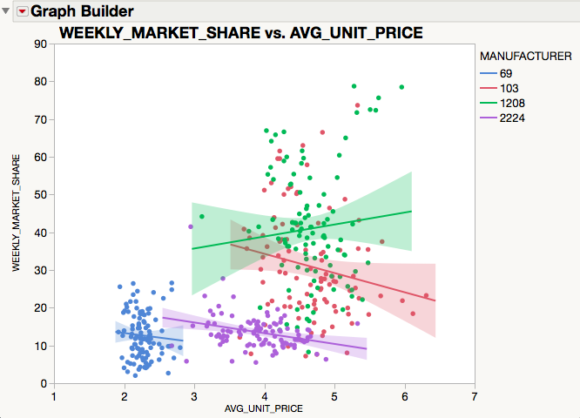

**Response WEEKLY_SALES_VALUE**

**MANUFACTURER=69**

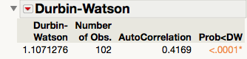

**MANUFACTURER=103**

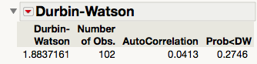

**MANUFACTURER=1208**

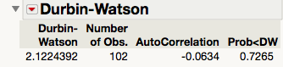

**MANUFACTURER=2224**

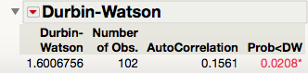

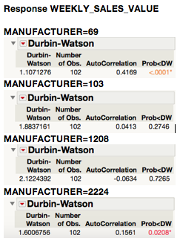

**Response WEEKLY_MARKET_SHARE**

**MANUFACTURER=69**

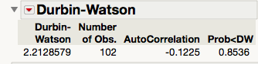

**MANUFACTURER=103**

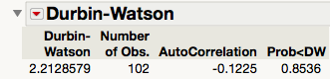

**MANUFACTURER=1208**

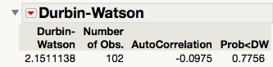

**MANUFACTURER=2224**

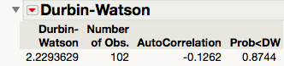

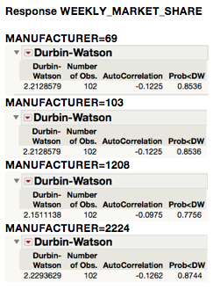

3

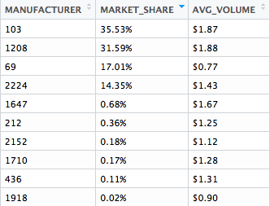

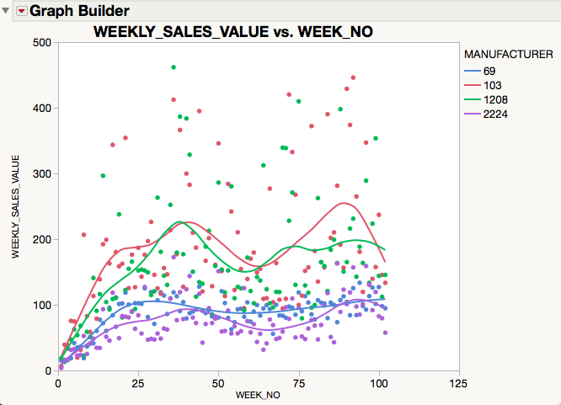

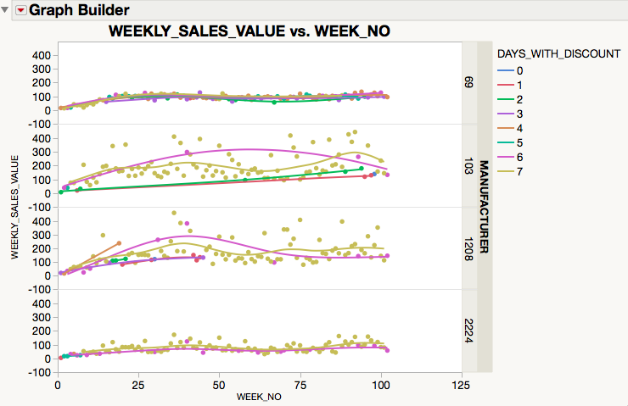

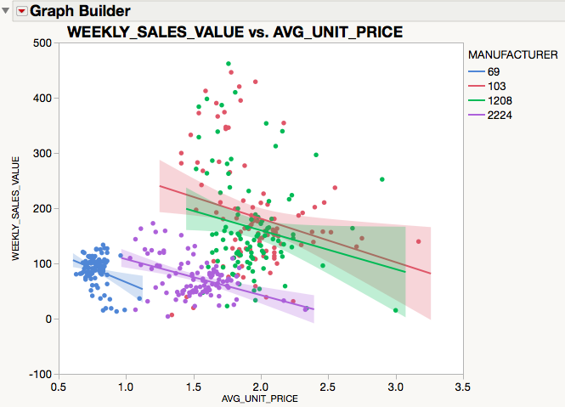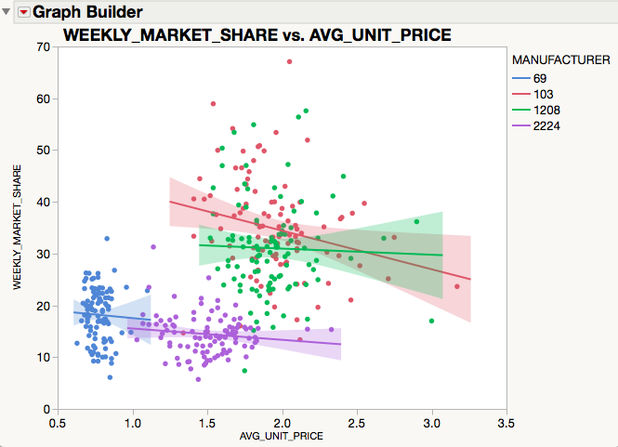

**Response WEEKLY_SALES_VALUE**

**MANUFACTURER=69**

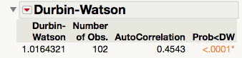

**MANUFACTURER=103**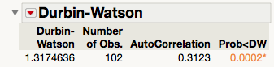

**MANUFACTURER=1208**

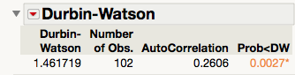

**MANUFACTURER=2224**

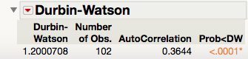

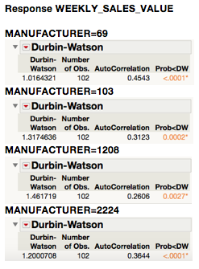

**Response WEEKLY_MARKET_SHARE**

**MANUFACTURER=69**

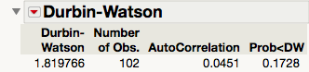

**MANUFACTURER=103**

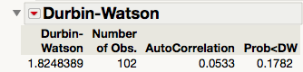

**MANUFACTURER=1208**

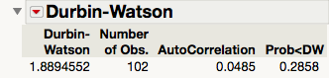

**MANUFACTURER=2224**

